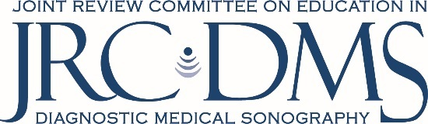
Curriculum Development and Education Experience Worksheet
Please electronically complete the information below in order to assist in assessing your experience in curriculum development.
Program Name: Program Number:

Personnel Name:

Personnel Position Title:

Academic Degree in a Major Related to Education:

Yes Details:
No
College/University Credit Course(s) related to Curriculum Development or Instructional Methodologies:
Yes Details:
No
Internal Educational Development Offerings:
Yes Details:
No
External Professional Continuing Education (conferences, seminars, etc.):
Yes Details:
No
New Course Development:
Yes Details:
No
Experience in Evaluation and Assessment:
Yes Explain:
No
If you answered “no” to any of the above, please explain how information and training in these qualification areas will be provided:

